Title of the Chapter
Title of the chapter in a second language (if applicable)

First Author Full Name^{1,*}, Second Author Full Name², Third Author Full Name³
¹ Department, Institution Name, Country.
² Department, Institution Name, Country.
³ Department, Institution Name, Country.
*Corresponding author: Email address and ORCID.

Abstract
The abstract should briefly describe (150-250 words) the purpose of the study, the methodology, key results, and the principal conclusions. It serves as a concise summary to help readers understand the article's scope. We recommend the following structure:
Keywords: keyword 1, keyword 2, keyword 3 (List from 3 to 6 relevant keywords related to the study that are useful for indexing and searches. Do not capitalize keywords, and separate them by a comma.)

Resumen (if applicable)
Please include the abstract in the second language if your article is written in Spanish or Portuguese. Otherwise, kindly remove this section.
Palabras clave: (If applicable)
How to cite: This is completed by the publisher.
Copyright: © XXXX The author(s). This article is distributed under the terms of the CC BY-NC 4.0 license, which permits copying and redistribution of the material in any medium or format, adaptation, transformation, and building upon the material, provided that the license terms are followed.

1. Introduction
The introduction provides the background and rationale for the study. It outlines the research question(s), objectives, and the significance of the research in the context of existing knowledge.
When preparing your manuscript, follow the guidelines set by the APA (American Psychological Association) Style, 7th edition. Below are the key aspects to keep in mind:
In-Text Citations:
- For direct quotes, include the author’s last name, year of publication, and page number (e.g., Smith, 2020, p. 15).
- For paraphrasing, include the author’s last name and year of publication (e.g., Smith, 2020).

1.1 Literature Review (if applicable)
A review of relevant studies, theories, or frameworks. This section contextualizes your research within the broader field and highlights gaps your work seeks to address.

3. Methodology
Provide a detailed description of how the study was conducted, ensuring replicability and transparency.

3.1 Data Collection (if applicable)
Describe the methods used for data collection (e.g., surveys, experiments, interviews), including any instruments, tools, or software employed.

3.2 Sample/Participants (if applicable)
Detail the characteristics of the sample, including selection criteria, size, and demographics.

3.3 Data Analysis (if applicable)
Explain the techniques or software used for data analysis (e.g., SPSS, R, NVivo). Specify any statistical tests or qualitative methods.

4. Results
Present your findings objectively and concisely. Use tables and figures to visually represent the data, ensuring they are appropriately labeled and numbered.
Tables
- Number all tables sequentially as Table 1, Table 2, etc.
- Provide a clear, concise title for each table.
- Tables should be formatted to be easily read, and column headers should be clearly labeled.
- Mention each table in the text (e.g., "As shown in Table 1...") and briefly describe what the table illustrates.
This is an example of a table:
Label 1 | Label 2 | Label 3 | Label 4
Data | Data | Data | Data
Data | Data | Data | Data
Data | Data | Data | Data
Data | Data | Data | Data
Table 1. Title of the table. Note: data generated by the software.

Figures
Label all figures sequentially as Figure 1, Figure 2, etc.
Each figure should have a descriptive caption explaining its content.
Submit each figure separately with a minimum resolution of 300 dpi.
Ensure all figures' axes, legends, and symbols are clearly labeled and legible.
Refer to figures in the text (e.g., "Figure 2 shows the distribution of...") and briefly interpret the data.
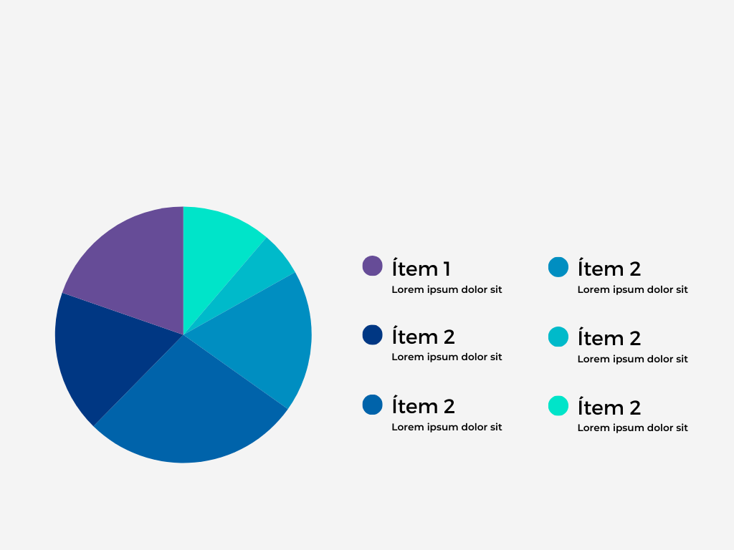
This is an example of a figure:
Figure 1. Title of the figure. Note: Prepared by the authors.

Note: Tables and figures should be placed within the text (where first referenced) or at the end of the manuscript, depending on the journal’s formatting requirements.
Footnotes
Footnotes should be used sparingly for additional explanations or citations that do not fit naturally within the main text. Number footnotes sequentially and place them at the bottom of the page or in a dedicated section before the references, depending on the journal’s guidelines.

5. Discussion
- Interpret your results, discuss their implications, and relate them back to the original research questions or hypotheses. Compare your findings to previous studies and explore potential explanations.
- Discuss the practical, theoretical, or policy implications of your results, offering insights into the broader significance of the study.
- Acknowledge any limitations of your study, such as sample size or methodological constraints, and how they might affect the generalizability of the findings.

6. Conclusion
Summarize the essential findings and their significance. Discuss potential future research directions based on your study.

Acknowledgments (optional)
Thank individuals, organizations, or institutions that provided research support, funding, or resources but are not listed as co-authors.

Funding (if applicable)
If the research has received funds, please declare that this research has received funds by [Institution name or equivalent] (grant number).

Conflict of interest
The authors should declare potential conflicts of interest or not.

Contribution statement
Based on the credit taxonomy, the role of each author must be placed here: https://credit.niso.org/

Statement of data consent
Authors must submit a data statement consent. These are some examples:
- The (Name/type of data) generated during the development of this study has been deposited in (Repository name), and it is accessible at (Data URL).
- The (Name/type of data) generated during the development of this study has been included in the manuscript.

References
List all sources cited in the text according to the APA citation style. Ensure all references are accurate and complete, with appropriate formatting for author names, publication years, article titles, journal names, volumes, issues, page numbers, and DOIs.

Appendices (optional)
Appendices provide supplementary material that is too detailed for the main text but is still relevant to the study (e.g., survey instruments, raw data, detailed calculations). Each appendix should be labeled as Appendix A, Appendix B, and so on, and referenced in the text as needed.
Example:
Appendix A: Survey Questionnaire.
Appendix B: Raw Data from Experiment 1.

